In order to keep consistency between the large aluminum pots and the smaller shapeways pots, we needed to translate the fin dimensions of length and depth from the smaller models to the new larger ones (fin width will not be scaled due to material limitations). These lengths were calculated by scaling the 2 inch shapeways pot designs to 15 inches, and taking those calculations into account.

Fin height will always be 17mm / 0.67”

The flaps should be at least 19mm / 0.75”

So when you cut out the fins make them 36mm / 1.42” wide/high/across

**Horizontal Fin Pot (Parallel Fins)**

7 parallel fins

The fins are varying in length, with one fin along the center of the pot and the rest spaced at 1.08 inch offsets in parallel to the center fin. So there should be 5 fins on either side of the center fin

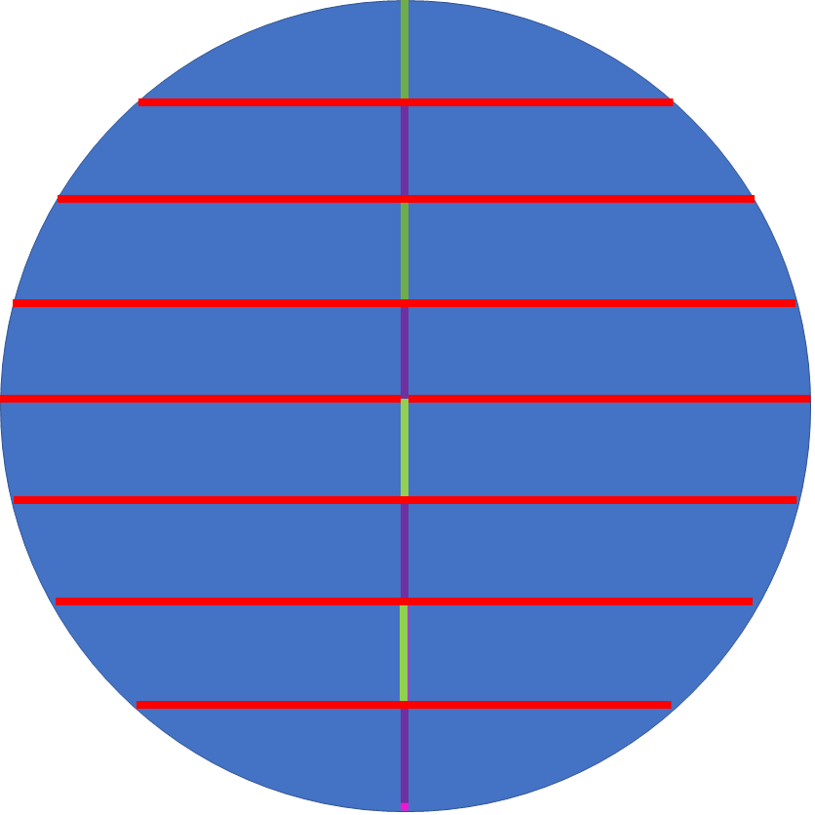

From the center the fins follow the following length:

Center fin: 8.66 inches 220 mm

1st Offset: 8.37 inches 212.6 mm

2nd Offset: 7.45 inches 189 mm

3rd Offset: 5.71 inches 145 mm

**Full Radial Fin Pot**

10 radial fins - 5.172 inches 131 mm in length

The fins are spaced equidistant along the pot, and start at the edge of the pot and point inward. They should reach the center of the pot, or at least close to it.

**Half Radial Fin Pot**

20 radial fins - 2.586 inches 66 mm in length

The fins are spaced equidistant along the pot, and start at the edge of the pot and point inward. They should only reach around halfway to the center of the pot